Experiment 3
Name: MD MAHMUDUR RASHID KHAN
Class: EIE
Student ID: F24010119

Title
Bode Plotter Analysis of Frequency Response in Filter Circuits
Experimental Principal
The principal purpose of this experiment was to investigate how the Bode Plotter is used to study the frequency response of electrical circuits. The experiment aimed to observe how output voltage changes with frequency, and how different filters such as low-pass, high-pass, band-pass, and band-reject circuits behave under varying signal conditions.
The Bode Plotter is especially useful because it displays gain or attenuation across a wide range of frequencies and can also show phase shift. This makes it an important tool for understanding how filters work in practical circuit analysis.
Introduction
A Bode Plotter is a device used to measure how a circuit responds to different frequencies. It displays gain or attenuation on a logarithmic scale and can also show phase shift, which makes it especially useful for studying filters. In this experiment, the Bode Plotter was used with RC and resonant circuits to observe low-pass, high-pass, band-pass, and band-reject responses.
Theory
The Bode Plotter compares output voltage to input voltage across a range of frequencies. In linear mode, the vertical axis shows voltage ratio, while in logarithmic mode it shows decibels. A cutoff frequency, also called the corner frequency, is commonly defined as the frequency at which the output falls to 70.7% of the input, or -3 dB.
For an RC low-pass circuit, low frequencies pass easily because the capacitor has high impedance at low frequency. As frequency increases, capacitor impedance decreases, causing the output voltage to drop. For high-pass, band-pass, and band-reject circuits, the response depends on resonance and the interaction of reactive components.
Result and Design
The first circuit studied was the low-pass filter, which was built using an RC network. This design allowed low frequencies to pass through more easily while reducing the output at higher frequencies. The measured results showed that when the output dropped to about 95%, the frequency was approximately 109 Hz; when it dropped to 70.7%, the frequency was about 332 Hz; and when it dropped to 10%, the frequency was about 3.3 kHz. The phase shift at the 95% point was about -18.198 degrees.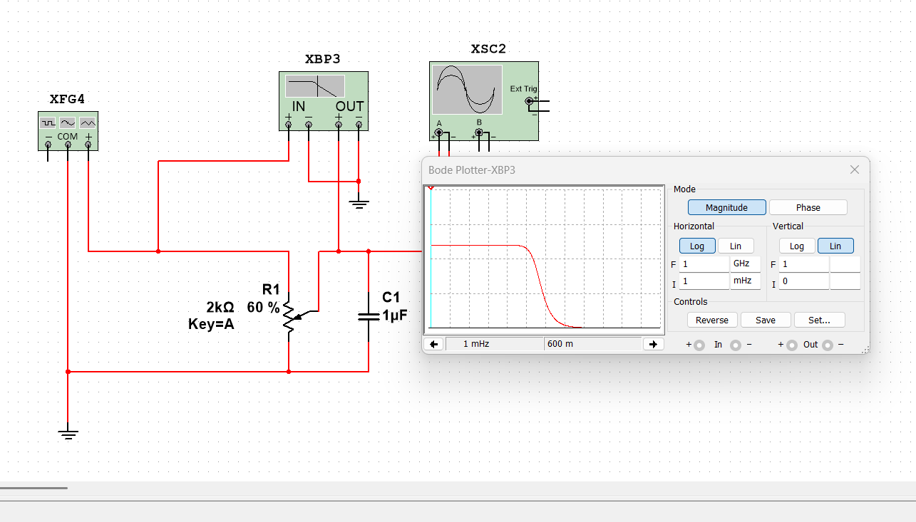

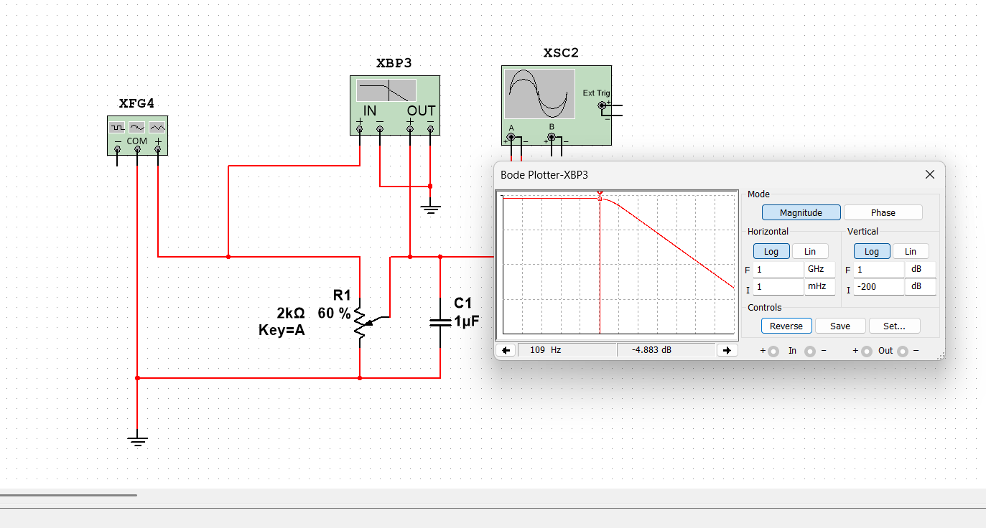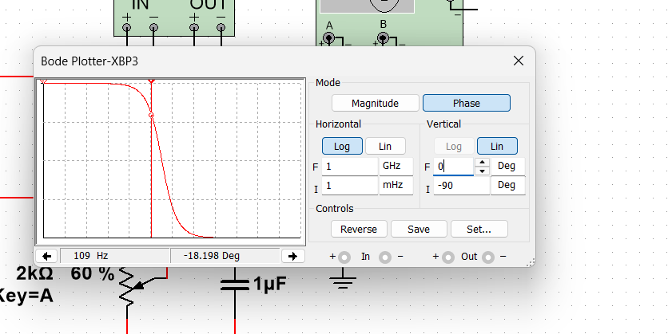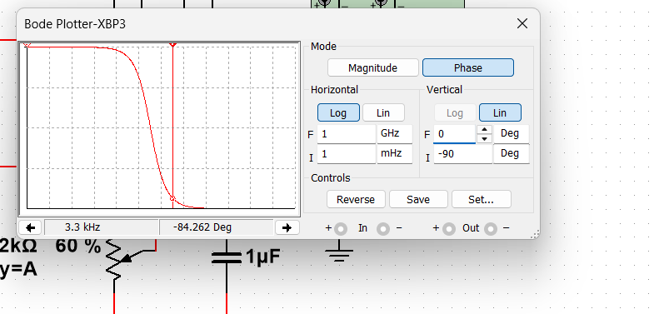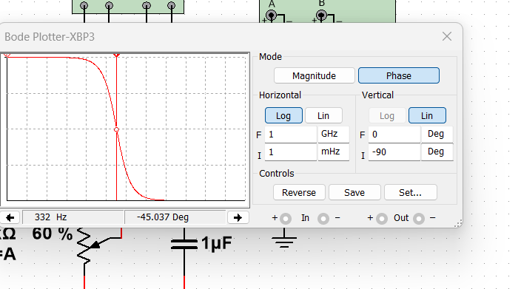
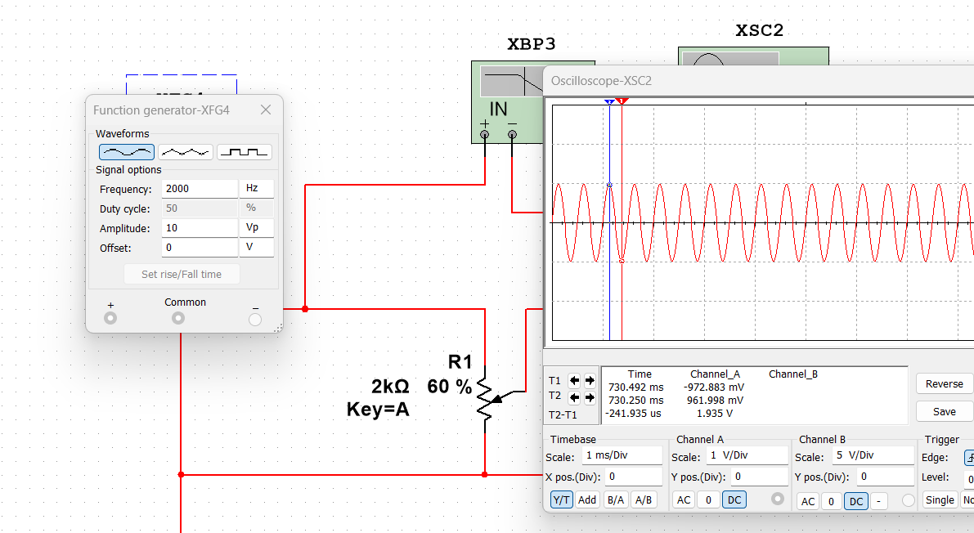
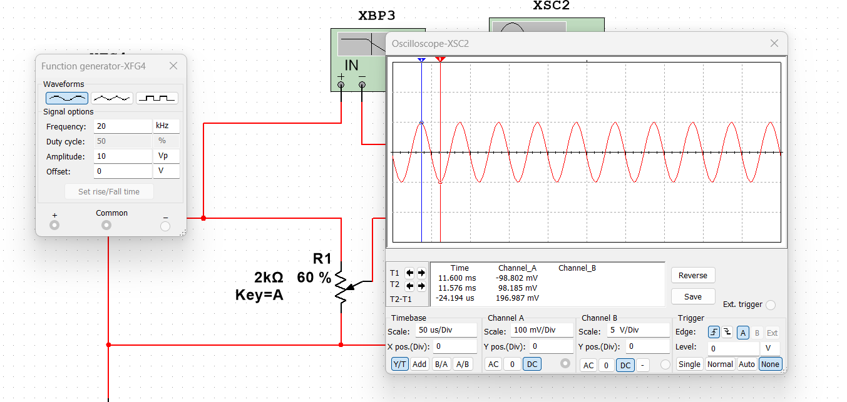
1. Double-click on the Bode Plotter to open it.
2. From the response curve determine the following:
a) When the output has dropped to (approximately) 95% , the RATIO of output to input is 0.57 ____0.6*0.95 = 0.57___.
b) The frequency at which this takes place is (108.979)_109_Hz.
c) Optional - Convert the input/output ratio to decibel notation. Show calculations.
（109Hz， -4.883dB ）
-4.293dB –((-4.437)=0.446
At__109__________Hz, the attenuation is 0.446_dB
3. At what frequency has the output dropped to (approximately)70.7% of the input?
0.6*0.707 = 0.4242
a) Freq. = ___332____Hz
b) Optional - Convert this ratio to decibel notation. Show calculations. Note that this is the or corner frequency.
(332Hz， -7.453dB
-7.453dB-(4.437Db) = -3Db
At__332____Hz, the attenuation is __3_dB
4. At what frequency has the output dropped to (approximately) 10% ? 1/10
0.6*0.1=0.06
a) Freq. = ____3300____Hz
b) Optional - Convert this ratio to decibel notation. Show calculations.
（3.3KHz，-24.4dB） -4.439dB
-24.439dB-（-4.437dB）= -20dB
At__3300_______Hz, the attenuation is __ 20____dB.
- Explain, without calculations, why the output decreases as frequency increases.
Working principle of RC low-pass circuit
When the frequency of the input signal is low, the impedance of the capacitor is higher than that of the resistor; Therefore, most of the input voltage drops on the capacitor (and both ends of the load, in parallel with the capacitor). When the input frequency is high, the impedance of the capacitor is low relative to the impedance of the resistor, which means that the voltage on the resistor decreases and less voltage is transmitted to the load. Therefore, low frequencies pass through and high frequencies are blocked.

6. Change the Bode display to PHASE and measure phase shift (leading or lagging) at the frequencies determined above.
a) Phase shift when output is 95% = __-18.198__degrees.
b) Phase shift when output is 70.7% = ___-45.037____degrees.
c) Phase shift when output is 10% = ____-84.262___degrees.
95% | 109Hz |  | -18.2
70.7% | 332Hz | 3dB | -45.037
10% | 3.3KHz | 20dB | -84.262

- Double-click on the Oscilloscope to open it. Observe the waveform. The frequency is 200 Hz.
The amplitude as measured on the scope is _5__V.
- Double-click the Function Generator. Change the frequency to 2000 Hz. The amplitude as measured on the scope is __1__V.
9. Change the frequency of the Function Generator to 20K Hz. The amplitude as measured on the scope is_0.1__V.
Note the difference in amplitude between the three readings. Is this what you would expect? Explain.
It shows that this is a low-pass filter
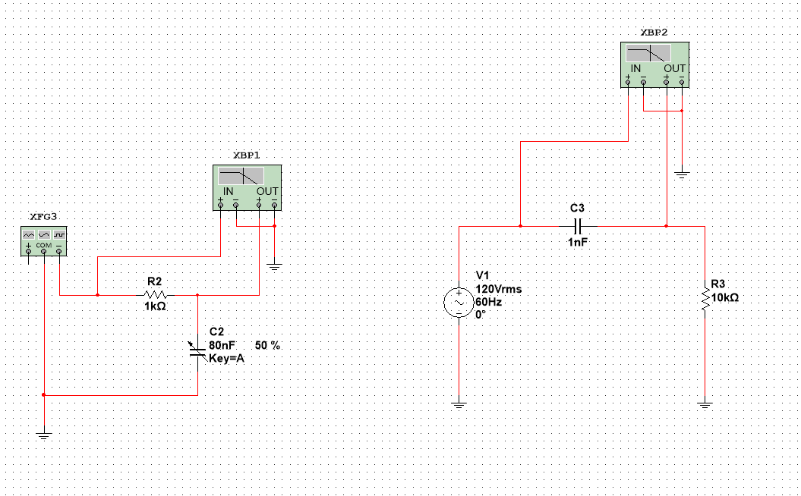
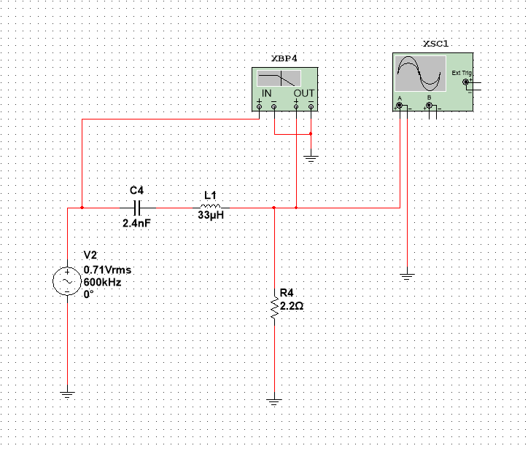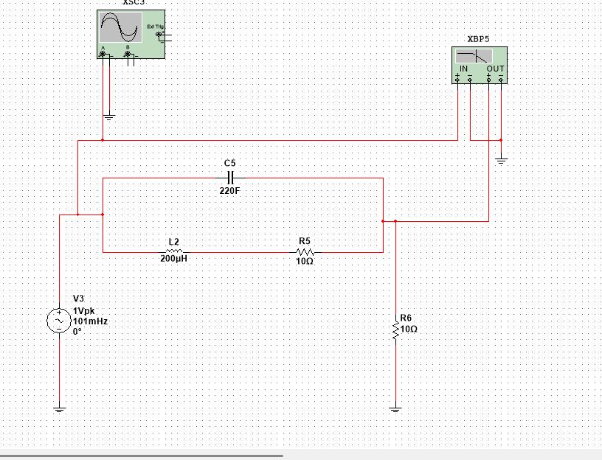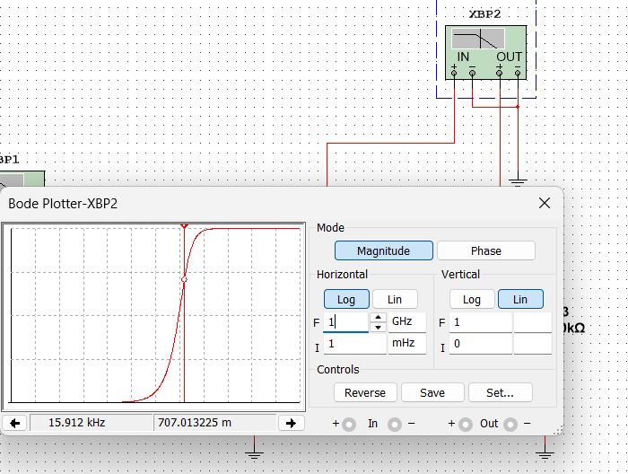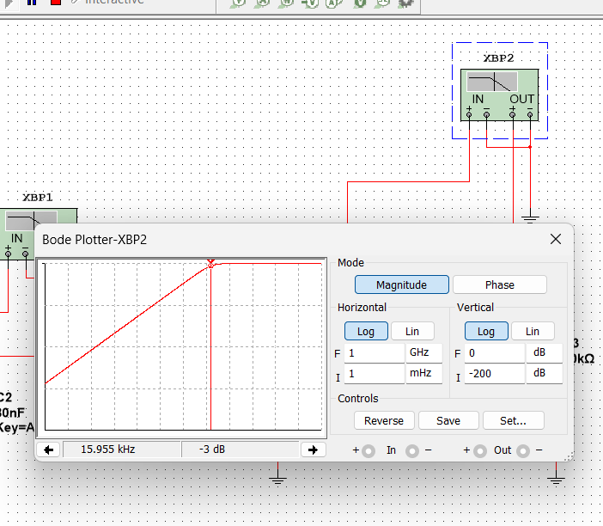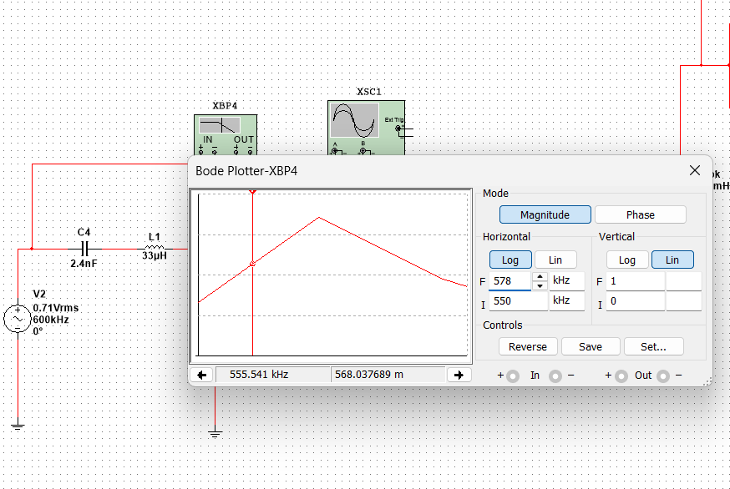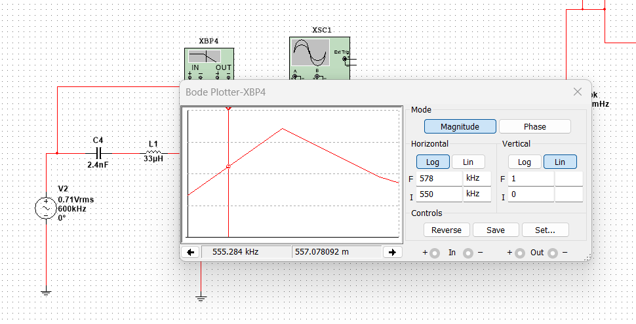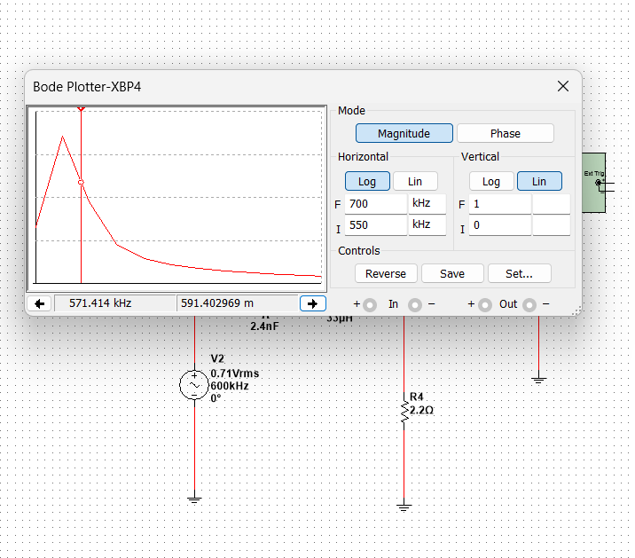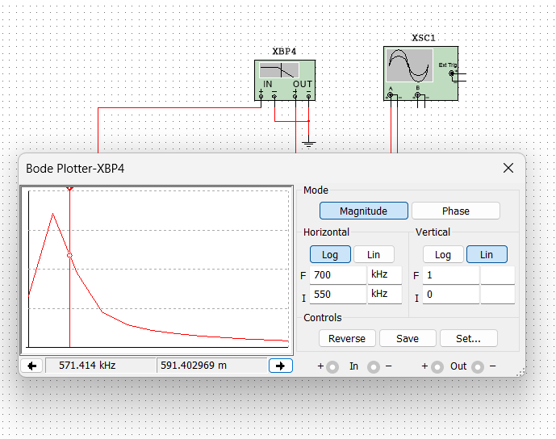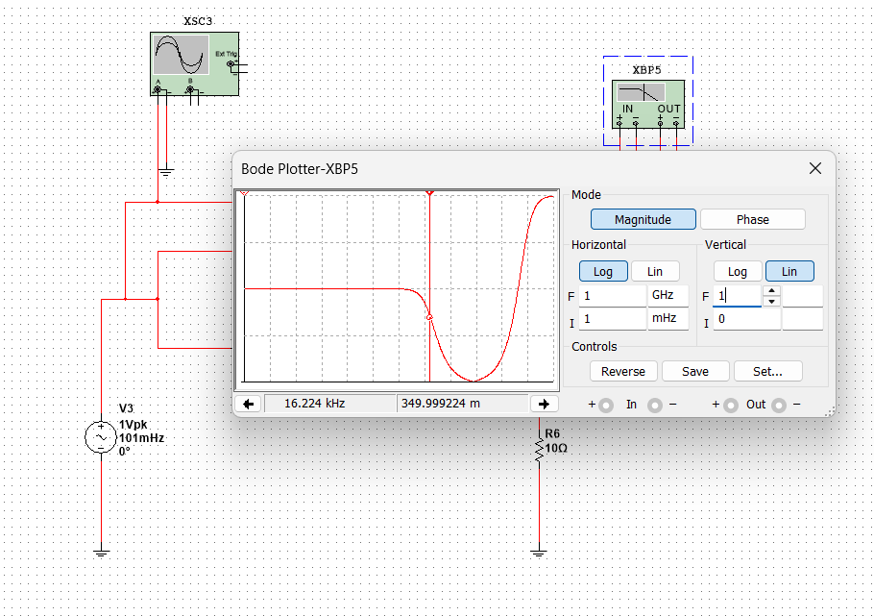
1. Double-click on the Bode Plotter to open its window.
2. Set the Bode coordinates to:
Vertical: LIN, F = 1, I =0
Horizontal: LIN, F = 50 kHz, I=1 kHz.
3. What type of filter response is this? Circle one of:
high-pass
low-pass
band-pass
band-reject.
4.Cutoff Frequency (also referred to as corner frequency) 70.7% 3dB
Freq.= ____3.98___ KHz.
Filter2.： high-pass
1.Cutoff Frequency (also referred to as corner frequency)
Drag the cursor until attenuation is approximately -3 dB and record the cutoff (or corner) frequency. 70.7% (Lin) 3dB(Log)
Freq.=__15.9______KHz.
2.ROLLOFF.
At two frequencies well below the cutoff frequency, one decade apart (a decade is a frequency ratio of ten), measure the attenuation to determine the rolloff. (suggest 100 Hz and 1 kHz or as close as the readout will provide).
Attenuation at (approximately 100 Hz) :
the attenuation is __44________dB 0-(-44dB)=44dB
Attenuation at (approximately 1 KHz):
the attenuation is _24______dB 0-(-24dB)=24dB
# Rolloff =___20dB_____ per decade.
100Hz 1000Hz 1000Hz/100Hz=10(decade)
-44dB -24dB -24dB-(-44dB)=20dB
Filter3
1. Run the simulation.
2. What type of filter is this?
Bandpass filter
3. Measure the resonant frequency and the voltage gain at the peak of the response curve. fo = __562____ kHz Voltage Gain= 0.8
4. Measure the frequencies at which the voltage gain has decreased to (about) 70% of gain at the peak (-3 dB).
0.8*
f1 (above Fo) = __571___kHz
f2 (below Fo) = _555____kHz
5. What is the difference between these two frequencies (the bandwidth of the filter)? Bandwidth = __16___kHz 571.4kHz-555kHz=16Khz

Filter4
1.Select Run under the Simulate menu (or click the ON switch).
band-reject.
2.Measure the frequency and the voltage gain at the valley of the response curve.
Valley frequency Fo = ___758KHz____ voltage gain= 0
- Measure the cutoff frequency
f1 (above Fo) =__72.331___Hz
f2 (below Fo) = __16.224__kHz
The band-reject width=___72. -0.0.02622M=___72.31_____

Conclusions from observations:
What is the relationship between the frequency and the bandwidth (approximately) for all circuits?

Low-pass bandwidth： cutoff(70.7%)-0Hz(I)
High-pass bandwidth: Final-cutoff(70.7%)
band-pass bandwidth: F1-F2 (High 70.7% - Low 70.7%)
The band-reject width: F1-F2 (High 70.7% - Low 70.7%)
The second circuit was the high-pass filter, which was designed to allow high frequencies to pass while attenuating low frequencies. Its cutoff frequency was measured at about 15.9 kHz, and the attenuation changed by about 20 dB per decade. This confirmed that the circuit blocked low-frequency signals more strongly than high-frequency signals.
The third circuit was the band-pass filter, which was designed so that only a narrow range of frequencies around the resonant frequency could pass efficiently. The resonant frequency was measured at about 562 kHz, with a peak voltage gain of about 0.8. The frequencies where the gain dropped to about 70% of the peak were approximately 555 kHz and 571 kHz, giving a bandwidth of about 16 kHz.
The fourth circuit was the band-reject filter, which was designed to block a narrow range of frequencies near resonance. The valley frequency was about 758 kHz, where the gain dropped to zero. The cutoff frequencies were measured at about 16.224 kHz and 72.331 kHz, giving a band-reject width of about 72.31 kHz.
Discussion
The results from the experiment show that filter behavior depends directly on frequency. In the low-pass circuit, the capacitor impedance was high at low frequency, so the signal was passed with little loss. As frequency increased, capacitor impedance decreased, causing more attenuation and reducing the output voltage. This is why the output fell gradually as the frequency rose.
In the high-pass circuit, the opposite happened. Low frequencies were strongly attenuated, but as the frequency increased, the circuit allowed more signal to pass. The rolloff of 20 dB per decade is consistent with the response of a first-order filter, which supports the accuracy of the measurement.
The band-pass filter showed a strong response only near its resonant frequency. This means the circuit was selective, allowing only a certain range of frequencies to pass effectively. The narrow bandwidth indicates that the circuit had a limited frequency window where the output remained high.
The band-reject filter worked in the opposite way by suppressing signals around a particular resonant frequency while allowing signals outside that region to pass. Together, these four filter types demonstrate the practical importance of the Bode Plotter in analyzing circuit performance across frequency ranges. The experiment also showed that bandwidth, cutoff frequency, and resonance are key characteristics used to describe filter circuits.
Conclusion
This experiment successfully demonstrated the use of the Bode Plotter in analyzing frequency-selective circuits. The measured responses confirmed the expected characteristics of low-pass, high-pass, band-pass, and band-reject filters. The results also showed how cutoff frequency, phase shift, resonance, attenuation, and bandwidth can be measured and interpreted in practical circuit analysis.
In conclusion, the Bode Plotter is a valuable instrument for studying how circuits respond to different frequencies. It helps explain both the mathematical and physical behavior of filters and gives clear experimental evidence of how electrical signals are shaped in real circuits.

